Section 3a: Knowledge Representation Essay

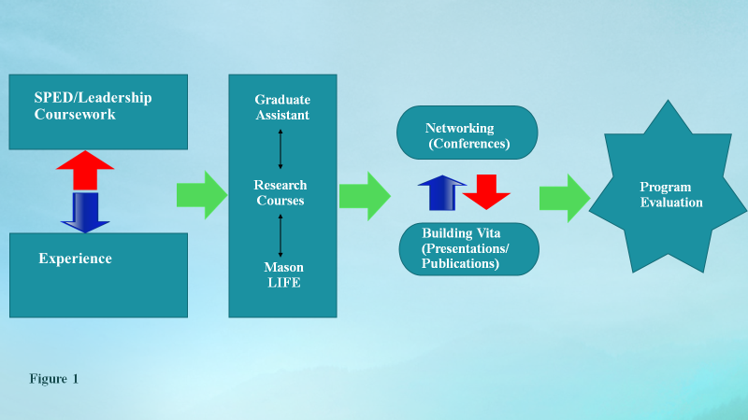
My program of study is centered around identifying, researching, and obtaining information, tools, and skills necessary to conduct program evaluations. The field of program evaluation varies depending on the area of interest (Mertens & Wilson, 2012). In EDRS 820, I learned about fundamental issues that arise in program evaluation. After considering multiple areas of interest, I narrowed down my area of attention to evaluating programs in a K-12 setting, focusing on students with learning disabilities (LD). Program evaluation coupled with specializations in special education leadership and educational leadership will afford me a multi-faceted approach to supporting students with LD. I created a visual display (Figure 1) of the strategic plan I am implementing to become an expert in program evaluation.
Leadership in Special Education
Throughout the last three years, I have taken special education leadership classes that have enhanced my understanding of the field. These classes gave me an opportunity to investigate the various challenges students with LD encounter in K-12 settings. One challenge that continues to resurface with students with LD is reading. In EDSE 841, I developed a meta-analysis to investigate measures used to evaluate interventions for reading comprehension for middle school students with LD and found the themes in measures were identifying the main idea, questioning, and summarization of the passage read. Additionally, I discovered that mega cognitive skills can have an impact on academic achievement. This study made me want to understand the variability in academic achievement between students with LD and their non-disabled peers. In EDUC 874, I took the opportunity to investigate an achievement gap in reading with students with LD compared to their non-disabled peers. Specifically, I learned how government polices affect the field of special education. I gained a better understanding of how No Child Left Behind (NCLB) increased the numbers of students with LD.
During my coursework in educational leadership, I have studied organizational theory and learned that organizations are open social systems (Harris, 2006). In EDLE 770, I developed a paper that had to consider social systems in a school. It was a case study that described what a principal should consider when implementing a new schoolwide initiative. My coursework aided my comprehension of how schools can successfully deal with systemic change. We need to understand that schools are organisms that function as single entities within a system, yet are needed to function as a single unit (Bolman & Deal, 2003). From my studies, I found that distributed and transformational leadership theory could be interwoven in an organization to ensure it is effectively functioning to support systemic change (Leithwood & Jantzi, 2000). The coursework has provided me with the tools to interpret school behaviors that encompass change.
My experience in public school as a special education teacher and administrator, has helped me make connections with my coursework and how it can practically be implemented in a public school setting. As a prior assistant principal, who oversaw the special education department in a secondary school, my experiences have mirrored my coursework. For example, I implemented interventions to support students with LD. I have had many evaluations in my department and saw the benefit of program evaluations. I am continuously combining my research knowledge with my practical experiences to gain a deeper perspective of special education leadership and ultimately program evaluations.
As a prior principal, I have experience leading schoolwide change. I have applied concepts from my coursework to introduce RTI/ PBIS, AVID, and the International Baccalaureate Program, among others within my school. I have firsthand experience with building a school culture that embraced distributed leadership and used transformational leadership to support systemic change. I have had experiences introducing and implementing programs that have had a positive impact on the school and programs that had questionable results.
Development of Research
My research method courses have played an integral role in providing me with a systematic format to develop and interpret research data. In my qualitative research coursework, I used methodologies such as interviews, focus groups, and direct observations to understand attitudes and beliefs. My quantitative coursework showed me, from empirical studies of large groups of people, how it can provide evidence of effects that generalize. The quantitative coursework explained relationships with data (Henson, Hull & Williams, 2010).
As a graduate assistant, I have had the opportunity to concentrate on the topic of reading as it applies to students with LD. I have researched topics about reading instruction, RTI, and presented and attended conferences (VCLD, CLD, AEA, and AERA). In Mason LIFE, I have applied my research knowledge. More specifically, Mason LIFE has allowed me to aid in implementing a reading program. This has sharpened my skills and knowledge in critically evaluating school structure, program design/ implementation, and staff/student perceived perspectives.
Networking
As I continue to grow my knowledge base through my coursework, it is crucial that I balance my ability to network, focus on building my vitae, and attend conferences. I will focus on presenting information to my colleagues in order to establish and gain credibility in the field. I will target conferences that focus on students with LD and program evaluation in education. I will also attend conferences to stay abreast of the changing research that is being done in the field of special education with students with LD and program evaluation. With a strong focus on networking, I will have the opportunity to gain additional skills. I will have access to decision-makers and thought leaders in the field of special education and program evaluation.

References
Bolman, L.G., & Deal, T.E. (2003). Reframing organizations: Artistry, choice, and leadership. San Francisco, CA: John Wiley & Sons.
Harris, A. (2008). Distributed leadership: According to the evidence. Journal of Educational Administration, 4, 172-188. doi: 10.1108/09578230810863253
Henson, R.K., Hull, D.M., & Williams, C.S. (2010). Methodology in our education research culture: Toward a stronger collective quantitative proficiency. Educational Researcher,39, 229-240. doi:10.3102/0013189X1036510
Leithwood, K., & Jantzi, D. (2000). The effects of transformational leadership on organizational conditions and student engagement with school. Journal of Educational Administration, 38, 112-129. doi:10.1108/09578230010320064
Mertens, D.M., & Wilson, A.T. (2012). Program evaluation theory and practice. New York, NY: The Guildford Press.

